Autoshooter

Published By:
Kastrar

Developed By:
Kastrar

Revision: 0.0.1

Document History

Version | Date | Summary | Author(s)
0.0.1 | 16/06/2023 | Pre draft V.0.0.1 | Kastrar

Document History
Game Summary
Target Platform(s)
Business Model
Game Overview
Theme / Setting / Genre
Core Gameplay Mechanics
Server / Online Mechanics
Push Notifications
Story and Gameplay
Story
Core Gameplay
Meta-Games
User Interface / Screens
Main Menu
Gameplay Screen
Premium Currency Store
Coins Store
Gear Shop
Settings Popup
Daily Reward Popup
Game Over Screen
Levels
Level Design Tools
First Time Experience
Economy
Asset List
Associated Documents

Game Summary
2D bullet hell autoshooter with permanent progression systems.

- Unique changes to weapons when leveling them up
- Ability to limit pool of available weapons for more consistent rounds.
- Quick game mode to play while in queue for other games like League of Legends.
- Full length mode to focus more on long term progression and as main game.

Target Platform(s)
- PC (androind/ios?)
- Any size window scaling accordingly.

Business Model
This will be a free to play game with micro-transactions. (video ads on mobile)

Game Overview

Theme / Setting / Genre
Show some example images or similar games / movies / books / TV shows with similar themes.

Core Gameplay Mechanics
Vampire survival, Goobies, Enter the Gungeon.

- Quick and rewarding mode for runs you might need to drop midway.

Server / Online Mechanics

- Steam Leaderboard
- Steam cloud

Push Notifications
?

Story and Gameplay

Story
Generic defend your self in a hostile world.

Not much of a story to tell, maybe item description for lore or secret drops saved in menu and read out loud.

Core Gameplay
A description of the game ‘loop.’

A flowchart is nice:
Upgrade
Character
Core Loop
-$
Enter Arena
Battle
Payout
To Winner
-$
+$
Unlock
New Arena
-$

Meta-Games
Character purchase, character level up, game wide upgrades.

More flowcharts!

User Interface / Screens
Wireframes of every screen or popup in the game and clear info on how they connect and lead to each other.

Numbering these sections makes them easy to find and you may even want to make a master flow-chart with ALL screens showing how each connects to the other.

Main Menu

- Game Logo
- “Play Now” Button - Goes to 2. Gameplay Screen
- “Store” - Goes To 3. Premium Currency Store
- “Settings”
- “Credits”

Gameplay Screen

123
+
Settings (See “6. Settings” Popup)
Gear Shop (See “5. Shop” Screen)
Coin (Soft Currency) Balance
Coin Store (See “4. Coin Store” Screen)
Level / Progress to Next Level

Player Hit Points

Enemy Hit Points

Open Daily Reward Chest
(See “7. Daily Reward” Popup)

5

Premium Currency Store

You know what to do here!

Coins Store

Maybe different from a premium store.

Gear Shop

Lala.

Settings Popup

Pop Ups too!

Daily Reward Popup

Pop Ups too!

Game Over Screen

And more!

Levels
Details about how many levels.

How levels will vary.

An example of a beginner level.

An example of a complex level.

A graph of the level “curve” which is usually starting easy as the player learns the game, getting a bit more difficult until the player faces off against a nerve-wracking “boss fight” or “challenge gate”, then sawtooth down to a bit easier again to let players relax.

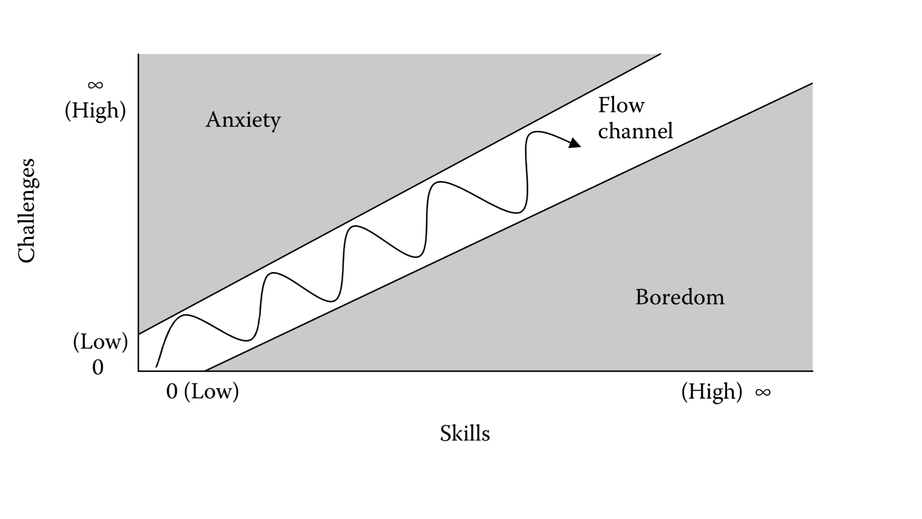

Level Design Tools
For example, is a tool needed for a designer to create and play-test levels?
How does it work exactly?

First Time Experience
Step by step.

Details of how a new player learns your game.

Economy
Link to Spreadsheet with tabs for all economy details. Such as:

- Info about premium currency:

USD | Coins
$0.99 | 100
$4.99 | 550
$9.99 | 1200
$19.99 | 2500
$29.99 | 4000

- Info about the soft currency.
- Info about experience points (XP).
- Info about leveling up.

Level | Total Exp Required | Delta XP For Next Level
1 | 0
2 | 5,000 | 5,000
3 | 15,000 | 10,000

- Info about unlocking things based on level.
- Info about everything you can ‘buy’ in the store or in the game:

Item | Position in Shop | Currency | Level  Required | Shop Value in Premium Currency | Shop Value in $
2x Booster | 1 | premium currency | 2 | 70 | 0.47
3x Booster | 2 | premium currency | 4 | 400 | 2.50

- Info about any other stats for combat, hit points, upgrading, etc.

Asset List
- Art
  - Note if 2D or 3D
  - If 3D Details on Textures and Poly Count
- Environment Art
  - All Associated Animations
- UI - Icons, Buttons, Pop Ups
- Game Objects
  - Buildings
  - Characters
  - Weapons
  - Tools
  - All Associated Animations
- Particle FX
- Sound Effects
- Music
- All Writing
  - Quest Scripts
  - Story ‘Screenplay’
- Level Design Documents

A big spreadsheet with columns and sections for each screen / major area is helpful:

Category | WORLD MAP | Description
Full Screen | Background | Background image that covers the whole scene
Icon | City 1 Icon | New York style
Icon | City 2 Icon | San Francisco style
Icon | City 3 Icon | Paris style
Sprite | Locked City | Big lock
Icon | Coming Soon | A banner that says ‘Coming Soon’
Category | ENVIRONMENT ASSETS | Description
Full Screen | Sky Background | 2D image of sky
3D | Rooftop | Roof shingles with chimneys, antenna, etc.

Associated Documents

- Full Asset List (Spreadsheet)
- Full Economy / System Design (Spreadsheet)
- Technical Design Document (TDD)
  - All Tools Used
  - Architecture Decisions
  - Cloud Hosting
  - Etc.
- Creative Design Document (CDD)
  - Mood Boards
  - Etc.
- Schedule (Spreadsheet)
  - A list of all milestones
  - What is in the milestone
  - Team to accomplish the milestone
  - Delivery date
- Budget (Spreadsheet)
  - IP / Brand License Costs
  - Software License Costs
  - Hardware Costs
  - Hosting Costs
  - Team Costs
    - Total
    - And Per Milestone
  - Marketing Costs

